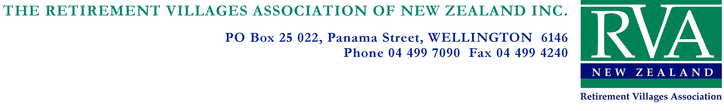

Getting the most out of your Associate Membership.

Associate Membership of the RVA has many benefits and this note explains how you can maximise your investment with us. Our village members are building around 32 units each and every week, and they are constantly looking out for new ideas, products and services. We are sure you’ll want to be part of that success.

There are lots of things you can do to get the most out of your membership and many of them are free (or cost very little).
- Making sure you’re listed on our website: We ask new associate members to provide us with a copy of their company logo and a brief sales blurb. We put these up on our Supplier Website. If you haven’t provided us with your logo or bio, then your company details won’t appear here. Please contact our Member Engagement Administrator, Emma Turner, (emma@retirementvillages.org.nz) if you think you should be on the Supplier Site but aren’t. You can change the bio, contact details or any other information that appears on our website about your company at any time. If you have a special offer, you can have it highlighted here for free – just let us know.
- Sector and Regional Forums: Associates are welcome to come along to our Forums; just let us know you’re coming, and we’ll make sure there are enough sandwiches to go around. Most RVA Forums are free for all members and associates to attend, but you may need to bring some money for lunch.
We try to have in some great professional development opportunities and fantastic, topical speakers. These could include you, if you have a subject that will be of general interest and isn’t an overt selling opportunity.
- Advertising in or contributing to our fortnightly newsletter: Members get a discounted advertising rate and it’s a great way to showcase your business or let members know about special events/offers. The newsletter is read by over 1,500 people who work in the retirement village industry around the country.
Submit a banner to Emma of the following dimensions to advertise, 600x75 pixels, at 72dpi (screen resolution). Cost is $180 + GST and payment is required prior to the publication of the advert.
You may want to consider submitting an industry-relevant article you’d like to share. For example, you may have received some advice about switching your company’s vehicle fleet to run on vegetable oil – why not share it with other members? The newsletter is a great place to do it. Contributions are always welcome.

- Using the RVA Database: We are happy to share aspects of our database with you. For example, we could alert you to new members who may not as yet have a fixed supplier and you could approach them to offer your services. We list new members in the email newsletter, which is another source of intelligence. Just let us know what sort of information you’re after and we’ll see what we can provide. We guard our membership details quite closely, so we are unable to give you some information, but all reasonable requests are considered. Nobody likes spam, so we won’t encourage you to do it to our members.
- Our Annual Conference is the major event in the RVA calendar. Our 2021 conference was held at the Cordis, Auckland and was attended by over 270 delegates and 56 exhibition stands. It included a trade show, study tours of local villages, plenary sessions, and an outstanding hospitality programme. Conference 2022 is to be held in Christchurch at Te Pae this August. We look forward to producing an impressive and influential event.

We take our responsibility to encourage our delegates’ engagement with exhibitors seriously, so we have introduced a world-first innovation using our conference app. As a result, we have had overwhelmingly positive feedback from our exhibitors.

- Sponsorship of Regional Meetings is available but actual events depend on the alert level at the time. We are looking at other opportunities for you to sponsor our activities. These could include sponsoring webinars or similar “virtual” activities where you will get a speaking spot where you can present your business to the members present. You are also free to run a short video if you wish as part of this. Please let us know if this is of interest so we can take that into account when planning our webinar programme.

We have other ‘ad hoc’ sponsorship opportunities arising throughout the year. If you wish to be considered for one of these, please let us know and we will approach you as the opportunity arises.

Essentially, your RVA membership can be a very valuable marketing and sales tool, but it has to be used. To get the best from your subscription, you must be proactive and put yourself out there among the members, get to know the industry and position yourself so you’re the person our members think of first when they want goods and services.

We look forward to working with you and helping you get the most out of your membership.

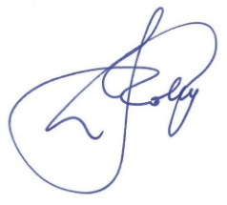
John Collyns
Executive Director

Feb 2021

